

Visiting National Parks
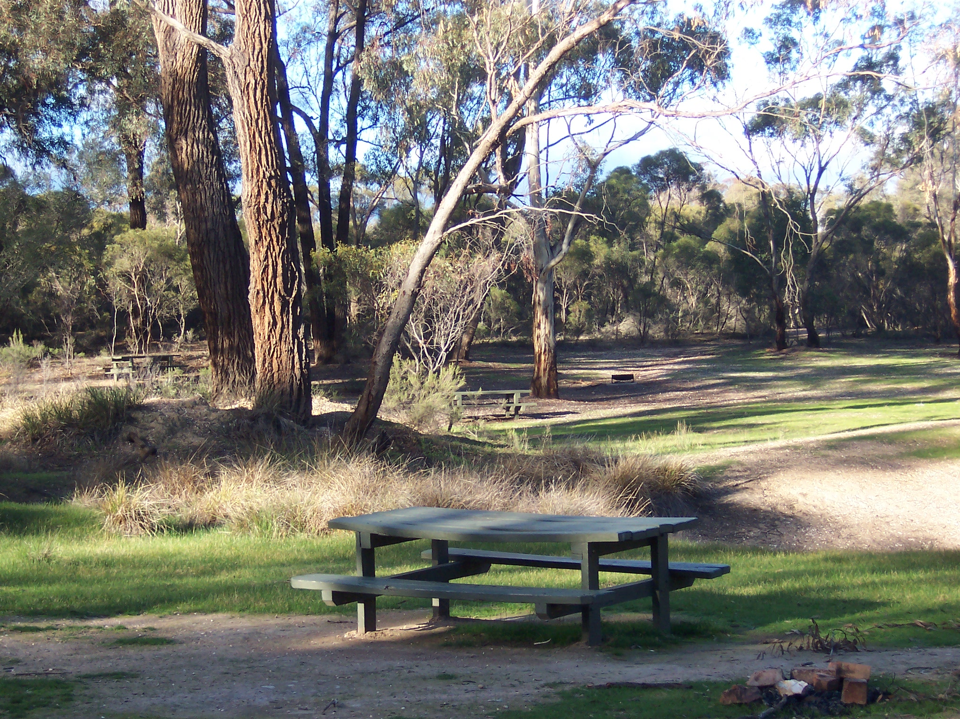
The Woodvale community is surrounded by the Whipstick National Park, residents should be aware that there are stringent regulations that apply to National and State parks.

Please observe all signage, and familiarize yourself with all applicable regulations.

The area is patrolled regularly by Parks Rangers, and severe penalties exist for infringements.

For further information please follow the link to the websites below:

http://www.parkweb.vic.gov.au/
http://www.visitvictoria.com/
http://www.austlii.edu.au/au/legis/vic/consol_reg/npr2003310/

