Woodvale Recreation Reserve Update January 2012
During late 2010 the Woodvale Recreation Reserve Committee of Management applied to the City of Greater Bendigo for $8092 through the 2010/11 round of “Small Township” grant for the purchase and installation of AFL and Soccer goalposts.
Our application was successful and after a total of 52 hours of voluntary labour the installation of the AFL goal posts was completed on 20th November 2011.
We also wish to acknowledge and thank the COGB for their significant monetary contribution and KB Excavations for their donation of services for the project.
A special thanks to all persons who contributed many hours of voluntary services to make this project possible.
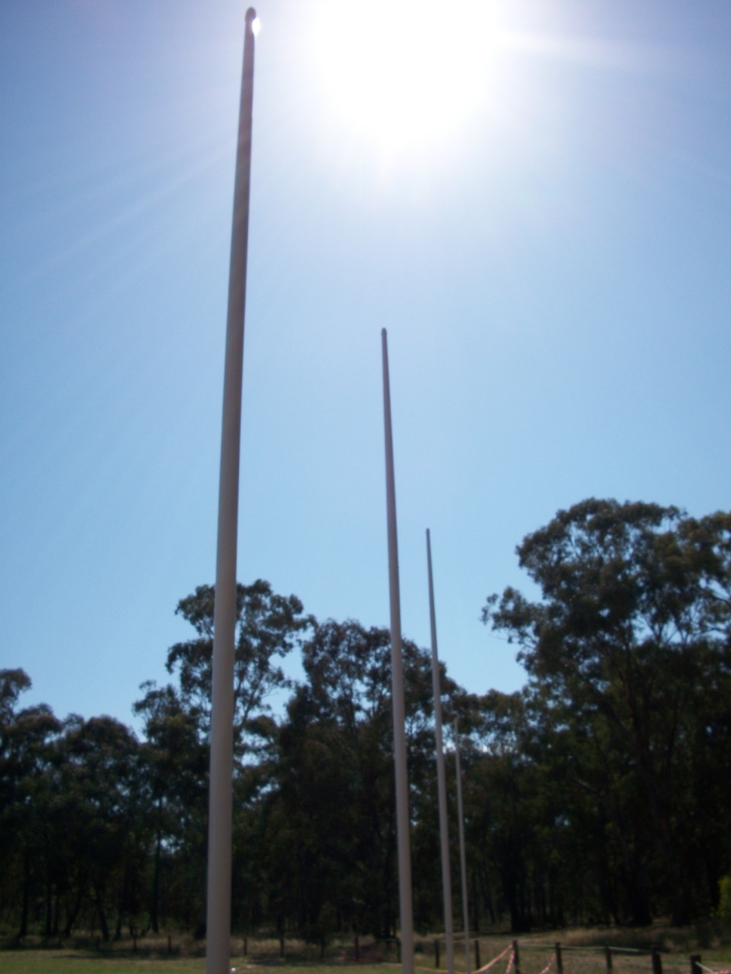We hope users enjoy the improvement made to the recreation reserve and actively encourage any club wishing to use the facilities to contact 5446 8643.

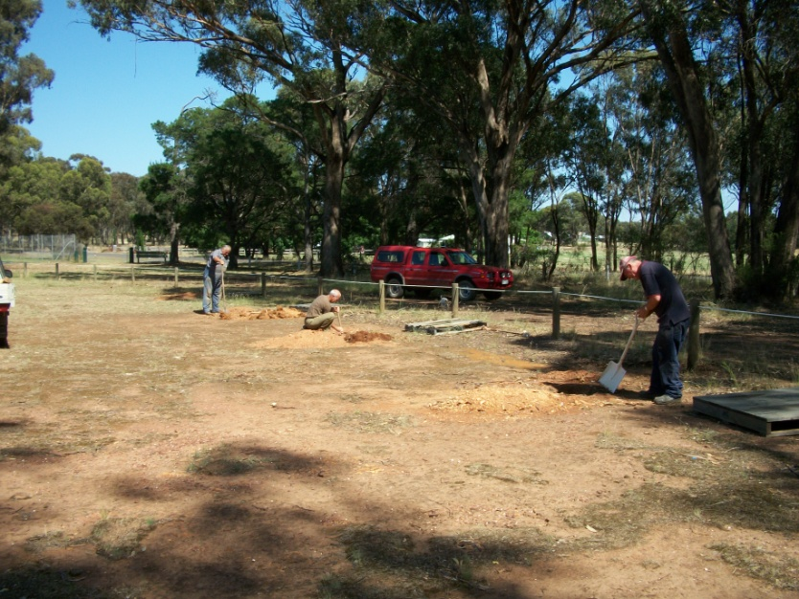

Installation of the AFL goal posts at the Woodvale Recreation Reserve November 2011