Anzac Ceremony Woodvale
6 am. 25th April 2020

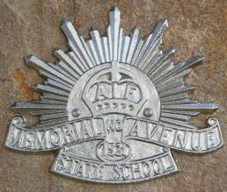

IN LIFE
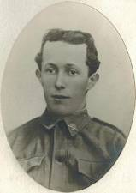
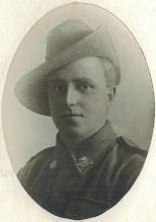
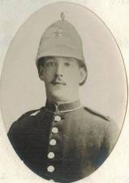
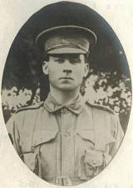
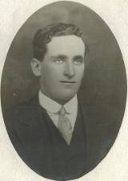
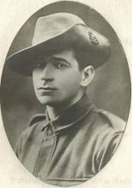
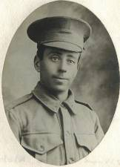

As a Woodvale and district resident, you are cordially invited to celebrate the ANZAC dawn service to be held at 6am, 25th April at the Woodvale Memorial Avenue. This is at the front of our Community Hall on Daly's Road. The location will be well signposted.

They grow not old, as we who are left grow old
Age shall not weary them, nor the years condemn
At the going down of the sun, and in the morning
We will remember them….

You are all invited to retire to the Woodvale Hall to enjoy a Complimentary Sausage Sizzle
Tea & Coffee is also provided

The Woodvale hall committee are seeking information of any local Defence force personal that may be mentioned in our dawn service. This information may be of a family member from great grandparent through to grandson or daughter, who may have served or are serving our country, particularly more recently conflicts or peace keeping events. A story that may seem of little relevance to some people at times, may give us a picture of their service for our country.
A pre Anzac day planning meeting will be held at Woodvale hall 26th of March @ 7.30pm for those wishing to volunteer help and more information.
Contact David Vaughan 0418522016 or email vaughans@woodvale.vic.au

