
The Woodvale Rural Fire Brigade

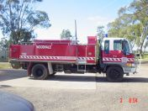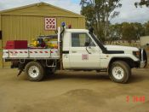

What: Brigade Meetings, CFA Volunteers
Where: Fire Station, Cnr. Rileys Rd & Loddon Valley Hwy.
When: First Monday of each month, commencing 7:30pm
Who: Captain: Darren Schultz, Tel: 0411573230

The Woodvale Junior Fire Brigade

What: Junior Fire Brigade Meetings
Where: Fire Station, Cnr. Rileys Rd & Loddon Valley Hwy.
When: To be advised
Who: Contact Captain….
------------------------------------------

