Minutes
Woodvale Progress Association
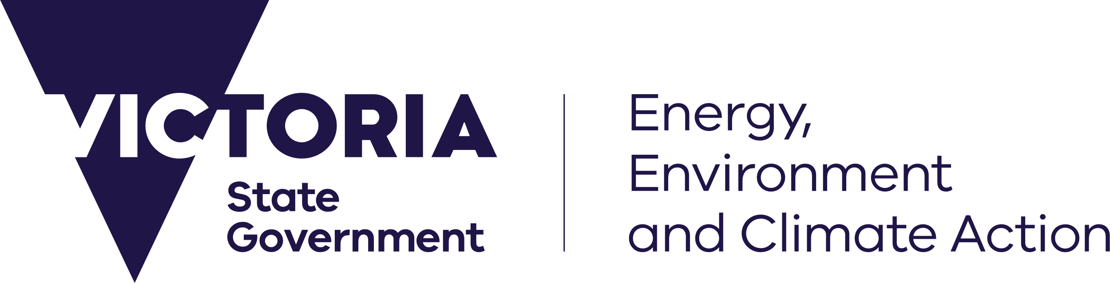
deeca.vic.gov.au

Date: | Friday, 6 October 2023
Time: | 11:00 AM
Venue: | Woodvale Hall
Attendees: | Earth Resources Regulation (ERR) Muthu Muthukaruppan (MM) Ben Gazi (BG) Peter Panozzo (PP) Eleanor Waters (EW) Woodvale Progress Association (WPA) Brendan Bartlett (BB) Gary Davies (GD) Glenys Hall (GH) Malcom Hall (MH)
Apologies: | Jacinta Allan Representative:  Jessica Ireland
Chairperson: | Muthu Muthukaruppan
Note taker: | Eleanor Waters

Item | Topic | Presenter
1. | Project update  Core sample removal  - 160/220 pallets of drill core restacked  - Restacking completion – 8 people, Bendigo Forklifts (9-12 Oct).  - Relocation to GSV Library (end Oct)  - Waste classification to inform landfill disposal and recycling options.  - Disposal options to be presented for approval (8 Dec)  - Disposal completion (end Dec).  Evaporation ponds rehabilitation  - Contract being finalised for detailed site investigation (DSI) to inform knowledge gaps in current Rehabilitation Plan  - Sampling when ponds are dry (later this year)  - Sampling sequencing ponds 7& 6,3-1  - Ponds to be refilled post sampling to manage dust.  - DSI completion (Q2).  Actions:  - ERR will seek review of the sampling, analysis, and quality control plan (SAQP) by WPA prior to execution (as part of the development of the DSI). – BG.  - ERR will inform WPA prior to completion of the remediation options assessment (as part of the development of the DSI). - BG | Ben Gazi
2. | Woodvale Progress Association business  - Pond 7 top 3 tiers most contaminated  - Don’t create a lot of dust as covered in vegetation.  - Dust impact during construction works is a big community concern.  Nearby residents south of ponds need to be consulted prior to summer.  - ERR will engage with neighbouring residents prior to Summer and provide community updates as and when required.  - Hall residence not impacted by dust.  - Request input into sampling and analysis plan, remediation option assessment  - Proposed sampling sequence of ponds 7 & 6, 3-1 to be planned in consultation with Coliban Water.  Actions:  - Assess coverage and dust on pond 7 top 3 tiers - PP.  - Liaise on community engagement and provide community information for display on WPA website and forwarding to the broader community group – EW.  - ERR to consult with WPA in sampling and analysis plan, remediation option assessment – BG/PP. | Gary Davies, Brendan Bartlett, and Glenys Hall
3. | Project Timeline  - Removal of drill core Q4 2023 (restoration work may be required after this time to ensure vegetation coverage is suitable)  - DSI will result in updated Rehabilitation Plan, remediation options assessment detailed design to expedite rehabilitation of the site.  - Civil works to commence Q3 2024  - ERR gave commitment to finding solutions to deliver in timeframe.  Actions:  - Nil | Ben Gazi
4. | Dust monitoring update  - Environmental Auditor noted Q1, Q2 dust monitoring results were not indicative of imminent risk(s) associated with nuisance dust and health.  - Small number of criteria exceedances for depositional dust – arsenic concentrations remain low and below investigation level.  - Ongoing inspections, monitoring, auditor review, dust management will be undertaken as required.  - WPA queried if there was a typographical error in dust report pg. 6, Q2.  Actions:  - Investigate dust report error – MM.  - Take photographs of pond 7 – PP. | Ben Gazi
5. | Other matters  - Community is asking when works will be complete.  - Post completion of the DSI and approval process, the duration for the full rehabilitation works is expected to take up to 2 years, contingent on the determined scope of works and the final rehabilitation option.  - Concerned there may be a risk of changes to committed project funding or prioritisation and dependant on DSI more funding maybe required for final scope of works.  - ERR reiterated commitment to progress the project and will seek further government funding if required.  - Ponds 4 & 5 require rehabilitation.  - Rehabilitation is undertaken but not tested.  - Remediation preference if offsite disposal can’t be secured, is encapsulation contained in one location using a polymer lining.  - Options contingent on DSI  - Some community members interested in options for end land use and have expressed interest in purchase.  - Disclaimed land - Currently freehold registration options are under investigation likely in name of the Minister for Energy and Resources. Consultation with Calum Walker in progress.  Actions:  - Review status to confirm proposal for ponds 4 & 5 - MM.  - Present remediation options – MM. | All

Next Meeting
The next meeting will be held in January 2023.

